# Implementation

## Options

At the beginning, I have 3 options to choose for my project, which is Raspberry Pi 4, Mega 2560 and Particle Argon.

The Raspberry Pi 4 is basically a Linux system and contain GPIO and Bluetooth module so that I can implement the remote lock system without buying another module and can be easy to fit to the breadboard. However, it is so obvious that the Pi4 have a bad power consumption compared to other two options.

|  |  |
| --- | --- |
| **Pi State** | **Power Consumption** |
| Idle | 540 mA (2.7 W) |
| ab -n 100 -c 10 (uncached) | 1010 mA (5.1 W) |
| 400% CPU load (stress --cpu 4) | 1280 mA (6.4 W) |

|  |  |
| --- | --- |
| **Mega 2560 v3 @ 9V** | **Power Consumption** |
| Reference Empty Script | 73.19 mA |
| Reduce Clock Speed | 61.76 mA |
| Low Power Mode | 26.87 mA |

|  |  |
| --- | --- |
| **HC-05** | **Power Consumption** |
| Maximum | 40 mA |

|  |  |
| --- | --- |
| **Particle Argon** | **Power Consumption** |
| GPIO | 82 uA |
| RTC | 81 uA |
| Analog | 82 uA |
| Serial | 520 uA |
| BLE | 141 uA |
| Network | 21.3 mA |

Therefore, I immediately drop the Pi4 option out of my box. Therefore, I need to think either I use Particle Argon or Mega 2560 + HC-05. I chose the second option at the beginning. There reason is that I did not compare the Power Consumption with Mega 2560 to Particle Argon at the beginning, it is because I think the Argon contain the Wi-Fi module which will using a lot of power compare the Mega 2560 without any network module.

## Mega 2560 + HC-05

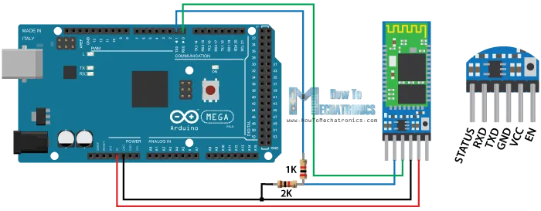At the beginning, I followed the article from Dejan to connect my Bluetooth module to the Mega 2560 following this diagram.

Fig - (Arduino and HC-05 Bluetooth Module Complete Tutorial, 2016)

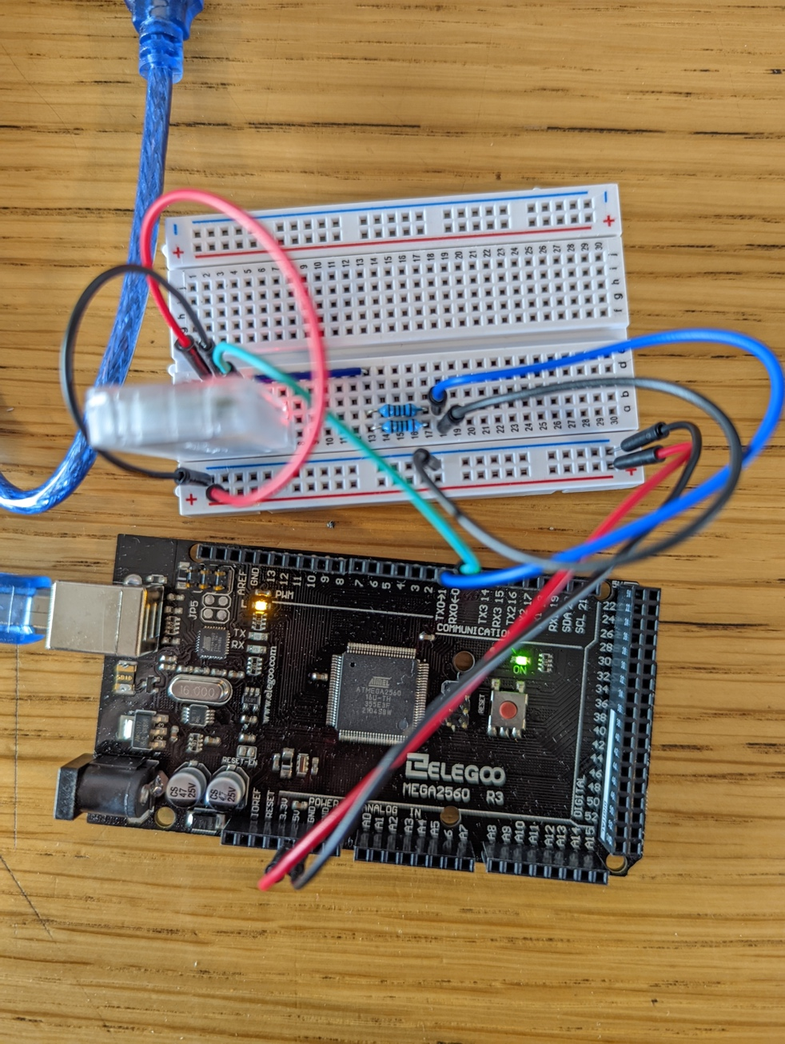

Fig –

And I was able to find the HC-05 using my Pixel 6 smartphone and I also created my own Android App – BTmsg using MIT App Invertor following the article from Dejan (How To Build Custom Android App for your Arduino Project using MIT App Inventor, 2016).

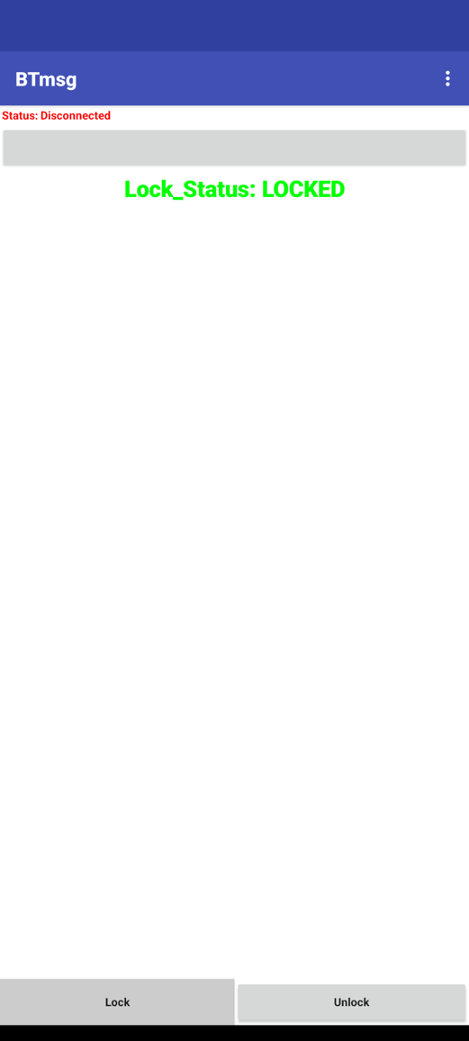

Fig – BTmsg

However, when I am testing the system, the Mega 2560 is not responding or not communicating with my HC-05 module.

|  |
| --- |
| **Testing Code** |
| if(Serial.available() > 0){ // Checks whether data is comming from the serial port  state = Serial.read(); // Reads the data from the serial port  Serial.println("waiting...");  }  else{  Serial.println("Fail...");  } |

When I am not plugging the Rx, Tx pin from HC-05 to Mega2560, it will keep outputting “Fail…”, which is correct. However, when I plug the Rx, Tx pin into the Mega2560, the Serial monitor not even show either “Fail…” or “waiting…” message, then I unplug the Rx, Tx pin, it continues to print the “Fail…” message again.

When I plug the Rx, Tx pin on, the Mega2560 just like it is stop responding anything, I tried around two hours and still cannot fix the issue, therefore I decided to change to my third option – the Particle Argon.

## Particle Argon

While I am searching for the documentation about the Particle Argon device, I found that the power consumption is relatively low compared to Pi4 and Mega 2560, it only takes about 30 mA for all module turned on. It only consuming 82 + 81 + 82 + 141 = **386 uA** when the Wi-Fi module set to off, and the Argon is 4-time smaller than the Mega2560. I was sock that how new device out playing the old device with that much, not only the size and power but also the documentation is much better than the Mega2560. Therefore, I decided to stay with Argon for my Project not thinking about going backward.

## Testing BLE

I can find an article (Wolff, 2019) about how to use the BLE API from the Particle Argon to receive data from other devices, and I am sock that it has Bluetooth Low Energy to use to more consume less power for the Bluetooth communication, that is the reason why the HC-05 is using 40mA but the Argon just use141 uA power for Bluetooth communication.

I am following the article from the beginning which I can change the device build in LED to different RGB colour.

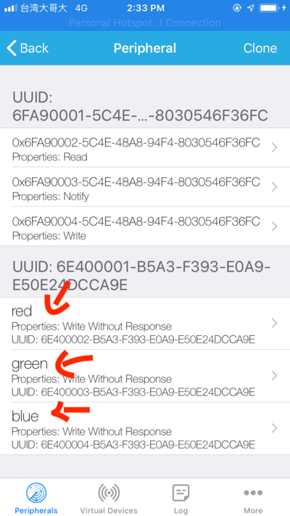

Fig - (Wolff, 2019)

## Wiring

After a successful test, I need to design my own code for receiving the locking command from the smart phone. In the meanwhile, I start to connect my HL-52S relay to the Argon board using digital pin 2 and pin 3.

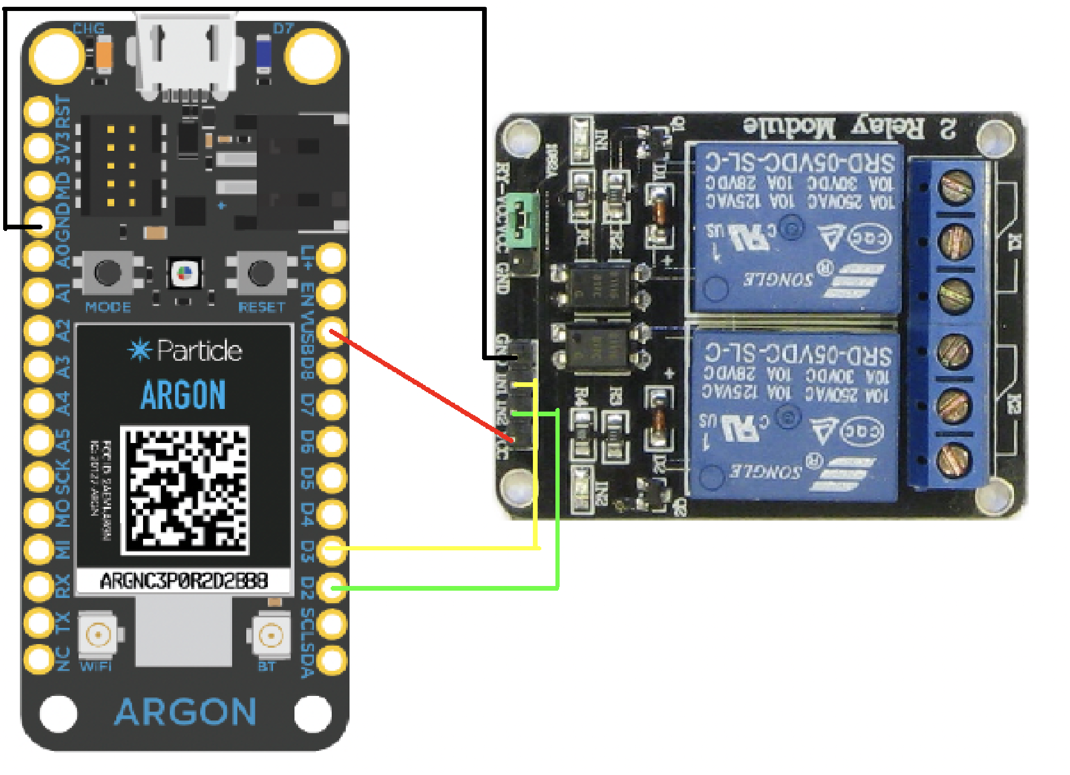

Fig-

Because I power it using USB cable, the Argon can output 5V power from the VUSB pin which is required for the HL-52S relay. Then I write some testing code to test if the relay is working.

|  |
| --- |
| Testing Code |
| // setup  pinMode(2, OUTPUT);  // loop  digitalWrite(2, HIGH);  digitalWrite(2, LOW);  delay(3000); |

Once I can hear the clicking sound from the relay, I can now connect the door lock motor to the relay. However, it has some issue when using the motor. To lock and unlock the door, I need to send the 12V DC to green wire when locking and reverse the order to turn the motor counter clockwise for unlocking and it also do not need to keep inputting the current to the motor, because it only need 100 ms to turn the motor to the full lock state otherwise the lock cannot operate manually.

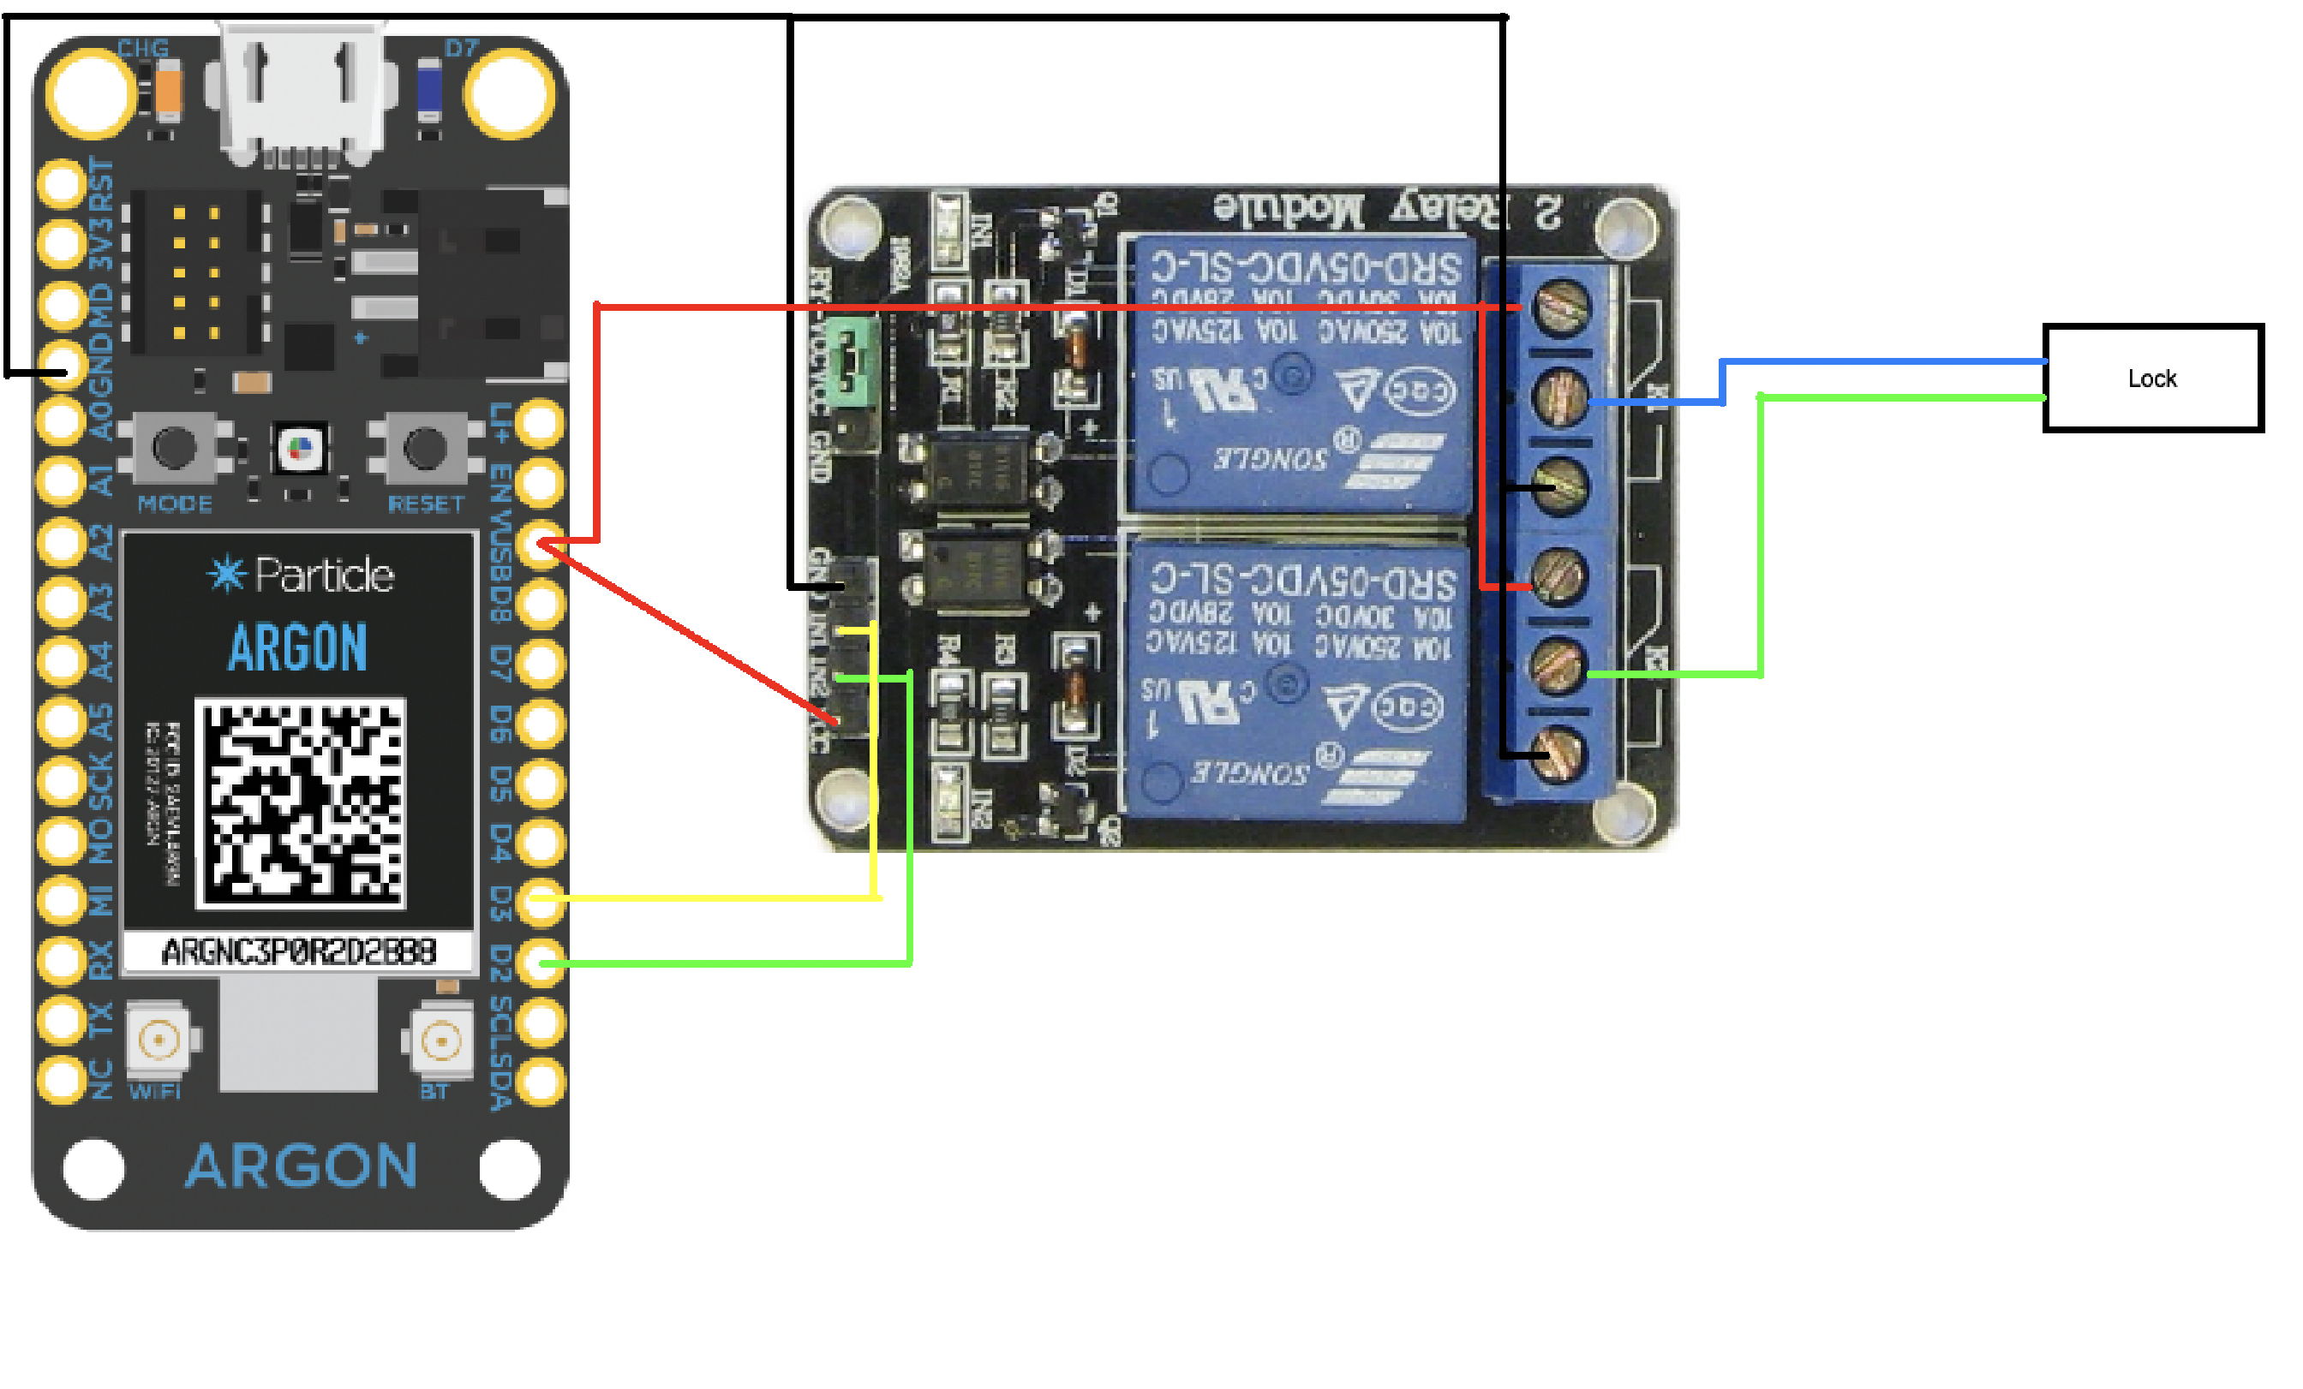

Fig –

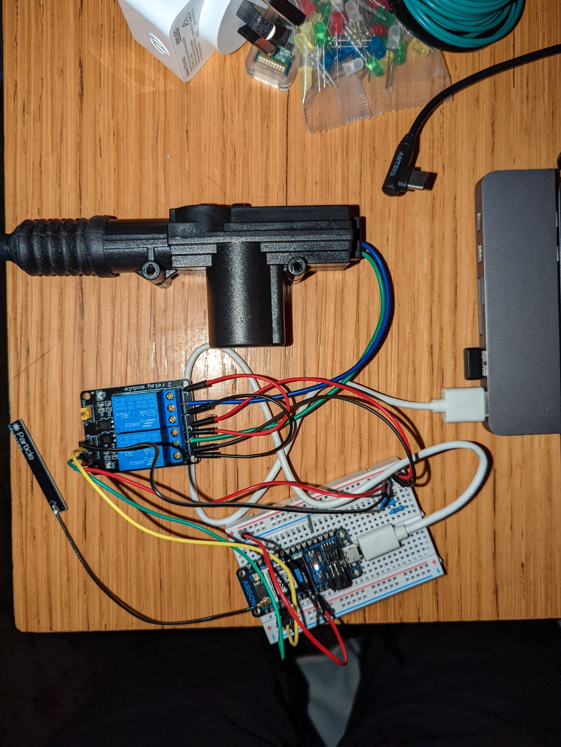

Fig -

For the testing, 5V is sufficient to turn the motor, however I will need to connect the high-power side to 12V when I install it on my car. Once the lock can lock and unlock using the relay, then I am able to design the algorithm that only the authorized client can be able to lock and unlock the door.

## BLE Algorithm

# Reference

How To Mechatronics. 2016. *Arduino and HC-05 Bluetooth Module Complete Tutorial*. [online] Available at: <https://howtomechatronics.com/tutorials/arduino/arduino-and-hc-05-bluetooth-module-tutorial/> [Accessed 2 June 2022].

How To Mechatronics. 2016. *How To Build Custom Android App for your Arduino Project using MIT App Inventor*. [online] Available at: <https://howtomechatronics.com/tutorials/arduino/how-to-build-custom-android-app-for-your-arduino-project-using-mit-app-inventor/> [Accessed 2 June 2022].

Wolff, J., 2019. *How to Use Particle's Powerful Bluetooth API*. [online] Jaredwolff.com. Available at: <https://www.jaredwolff.com/how-to-use-particles-powerful-bluetooth-api/> [Accessed 2 June 2022].